Crossroads
Finished quilt: 60 ½’’ X 60 ½’’
Finished Block: 6’’ X 6’’

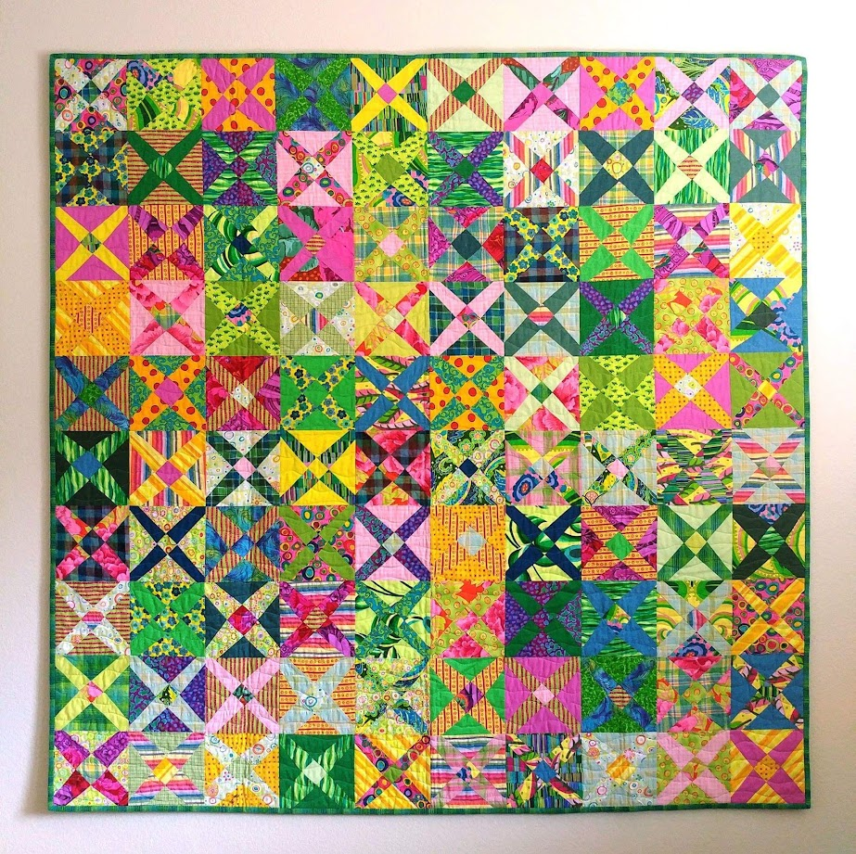

Class description
Freeform blocks are abstract interpretations of traditional quilt blocks. How would you like to make quilt blocks without templates and marking, with as few measurements as possible? See what happens when you let loose and embrace the imperfections and irregularities of human hands. Every block is different than the next, yet there is an overall harmony and balance to the quilt.
You will learn to trust your instinct and eyeballing skills to make a whimsical quilt with a personality.

Yardage Requirements for the quilt top 60” X 60”

Blocks:
1/3 yard each, total of 25 prints and solids
Backing:
4 yards

Binding:
⅝ yard

Batting:
Twin

Tools
Medium size cutting mat
Rotary cutter with fresh blade ( very important)
6'' x 12'' ruler with extra blade
Scissors
Rotating Mat (optional)
9 1/2'' Square ruler (Optional)
A sewing machine in good condition with its basic accessories

Pre-Class homework
Pre-wash and iron fabrics if preferred
Follow the cutting instructions and pre-cut squares

Cutting the fabrics

From each 1/3 yard:
Cut 1 strip 9’’ X width of the fabric. Crosscut 4 squares 9’’ x 9’’
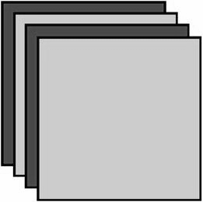
Make 25 stacks of squares each containing two dark and two light squares. With the right sides up, arrange them in alternating order. Pin each stack for easier handling.

My book is Cultural Fusion Quilts. I highly recommend that participants have it on hand. It is filled with 15 fun projects. The whole process of freeform blocks is pretty addicting, and I hope they make more than just one quilt.

Sujata Shah
Author of Cultural Fusion Quilts
Blog: http://therootconnection.blogspot.com/

