Windmills
Finished quilt: 48 ½’’ X 48 ½’’
Finished Block: 6’’ X 6’’

Class Description
Inspired by the windmills of Pennsylvania farms and Sujata's childhood memories of paper pinwheels, Windmills is a beginner-friendly project.
Participants will use a simple five step process to make an art quilt with free-form traditional blocks. With easy-to-follow instructions from the book Cultural Fusion Quilts, this class is designed to focus on cutting curves through multiple layers of fabrics and sewing curved seams. Individuals will construct blocks resembling an appliqued leaf using a carefree and fun technique. Participants will also explore possibilities of various layouts by changing the orientation of their blocks.
Sujata will share many tips on making Free-Form blocks and offer many suggestions for color combinations and layouts during the class. You may not stop at just one.

Yardage Requirements for the quilt top

Blocks:
¼ yard each of 16 assorted solids

Tools
Medium size cutting mat
Rotary cutter with fresh blade
6'' x 12'' ruler
Scissors
Rotating Mat (optional)
9'' or 12'' Square ruler

Pre-Class homework
Pre-wash and iron fabrics if preferred.
Follow the cutting instructions and pre-cut squares.

Cutting the fabrics

From each 1/4 yard:
Cut 1 strip 8’’ X width of the fabric. Crosscut 4 squares 8’’ x 8’’ for a total of 64 squares for the blocks

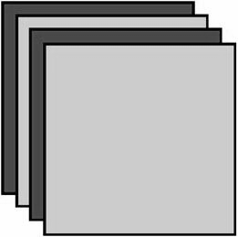
Make sixteen stacks of squares each containing four contrasting squares. With right sides up, arrange them in alternating order. Pin each stack for easier handling.

Sujata Shah
Author of Cultural Fusion Quilts
Blog: http://therootconnection.blogspot.com/
Email: sujatashah450@gmail.com

